**GOU-CSC121 (HUMAN-COMPUTER INTERACTION (HCI))**

**Goals/Study Objectives**

1. Understand the historical development of Human-Computer Interaction (HCI) and the key theories behind it.
2. Identify fundamental concepts in HCI, such as interaction models, usability, and user-centered design principles.
3. Explore current HCI practices across various industries and understand their practical implications.
4. Analyze the basic components that make up human-computer interaction systems, including hardware, software, and user interfaces.
5. Critically evaluate the impact of computer-based technologies on society, communication, and everyday human activities.
6. Examine HCI from a user-oriented social perspective, focusing on how individuals and groups interact with technology.
7. Assess the cognitive aspects of HCI, exploring how users process information, perceive systems, and make decisions.
8. Evaluate the system-oriented approaches to improving users' technological experiences and enhancing system usability.
9. Investigate interaction styles and device perspectives, learning about various input/output devices and their roles in user interaction.
10. Learn design guidelines, rules, and principles that guide the creation of effective and user-friendly systems.
11. Apply evaluation methods to assess the usability and functionality of interactive systems.
12. Understand participatory design approaches, involving users in the design process to ensure solutions meet their needs.
13. Identify system interactive design patterns, exploring commonly used patterns in designing interactive systems and user interfaces.
14. Design basic user interfaces by applying core concepts and best practices to create intuitive and accessible interfaces.
15. Utilize user interface design tools and programming techniques to build, prototype, and improve interactive systems.

**Course Contents**

**Module 1: Survey of Human-Computer Interaction Concepts, Theories, and Practice**

Unit 1 Concepts, Theories, and History

Unit 2: Survey of Human-Computer Interaction Practices

Unit 3: Basic Components of Human-Computer Interaction

Unit 4: Critical Evaluation of Computer-Based Technology

**Module 2: User Perspectives of Human-Computer Interaction**

Unit 1: User-Oriented Perspective of Human-Computer Interaction-Social Human Thrust Unit

2: User-Oriented Perspective of Human-Computer Interaction-Cognitive Human Thrust Unit

3: System-Oriented Perspective of Human-Computer Interaction-Improving The User's

Technological Perspective

Unit 4: Devices Technological Perspective-Interaction Styles, and Devices Technological

Perspective

**Module 3: Designs of Human-Computer Interaction**

Unit 1: Design Guidelines, Rules and Principles

Unit 2: Evaluation Methods

Unit 3: Participatory Design

Unit 4: System Interactive Design Patterns

**Module 4: Design of User, and System Interfaces**

Unit 1: Design of User Interface Concepts

Unit 2: User Interface Design Principles and Criteria/Rationale

Unit 3: User Interface Design Programming Tools

Unit 4: The Software Design Process of Human-Computer Interaction

Unit 5: Interactions in Hypertext, Multimedia, and The World Wide Web

**Module 1: Survey of Human-Computer Interaction Concepts, Theories, and Practice**

Unit 1 Concepts, Theories, and History

Unit 2: Survey of Human-Computer Interaction Practices

Unit 3: Basic Components of Human-Computer Interaction

Unit 4: Critical Evaluation of Computer-Based Technology

**1. Introduction to Human-Computer Interaction (HCI)**

HCI is a branch of computer science that is concerned with the design, implementation, and evaluation of user interfaces (UI) for human use. A device that allows interaction between a human being and a computer is known as a human-computer interface.  It has grown over the decades to include types like text-based interaction systems or command-line interfaces, graphical user interfaces (GUI), **gesture-based interfaces,** and voice user interfaces (VUI) for speech recognition and speech synthesis.

.

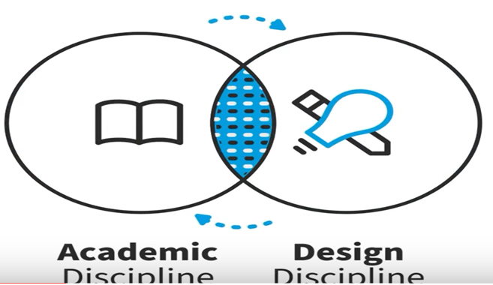

Figure 1: HCI sides.

There are two sides to Human-Computer Interaction (HCI). One side is the academic discipline, which is about the study of the way people interact with technology or computer technology. On the other side, there is the design discipline (this is about how you can create interventions with technology that make a difference to people). In summary, one side is about studying computer technology and its impact on people, while the other side is saying how to practically change that academic information we have into action or design things effectively.

[**What is Human-Computer Interaction (HCI)?**](https://www.interaction-design.org/literature/topics/human-computer-interaction?srsltid=AfmBOopHtvYrpgIZwxT7SyB-yhhJC1hhV_nptTKk76ZxIX5CZTq9U-Bl#what_is_human-computer_interaction_(hci)?-0)

Human-computer interaction (HCI) is a **multidisciplinary** field of study focusing on the design of computer technology and, in particular, the interaction between humans (the users) and computers. John M. Carroll, in the encyclopedia of human-computer interaction, 2nd edition, explains HCI initially as a specialty in computer science, which included cognitive science and human factors engineering.

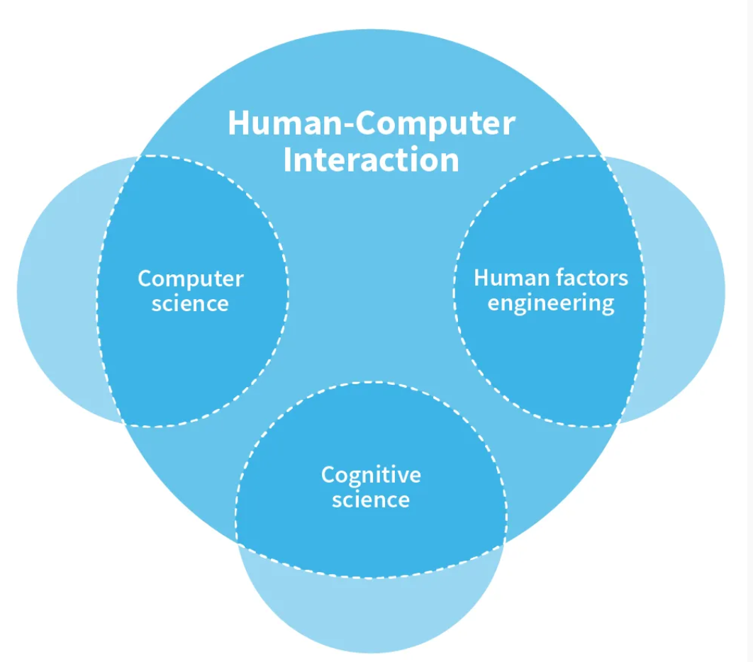

Figure 2: Multidisciplinary field of HCI

**What should you learn from studying HCI?**

**Facts:** The facts about the nature of computers, human psychology, and social interactions.

**Analysis:** This is all about looking at situations and drawing meaning from them, picking up problems or opportunities, and gaining a better understanding of them.

**Design:** This concludes the analysis. After doing your analysis together with the facts gathered, you can do a design job in order to synthesize them and create a solution to a problem.

**Attitude of mind:** It sees real people and real users as a center place. It’s about seeking to understand people, however different they are from you, and to do things that are good for them and make sense in their lives.



Figure 3: What you should from studying HCI

**1.1 Key Concepts in HCI:**

**HUMAN**

**COMPUTER**

**INTERACTION**

**Human**: Refers to the users of the system and other people they work with and communicate with.

**Computer:** The machine or network of machines that run the system the human is using. It refers to any technology that processes information, ranging from personal computers, smartphones, and tablets to more complex systems like robots or artificial intelligence (AI).

**Interaction:** This is the interface that represents the system to the users. It refers to the communication process that happens between the human and the computer, often through an interface such as a keyboard, mouse, touchscreen, or voice commands.

**1.2 Key Principles of HCI**

There are seven key principles of HCI, these principles help make technology more intuitive, efficient, and user-friendly.

1. **User-Centered Design:** Focuses on designing systems based on the needs, preferences, and abilities of users to ensure ease of use.
2. **Consistency:** Interfaces should have a consistent design across different elements, making them predictable and easier to learn.
3. **Feedback:** Systems should provide clear feedback to users after every action to let them know whether their input was successful.
4. **Error Prevention:** Good design minimizes the chances of user errors, and when errors occur, it should be easy to correct them.
5. **Flexibility:** Systems should accommodate different user preferences and levels of expertise, allowing for both novice and expert use.
6. **Accessibility:** Interfaces should be designed to be usable by as many people as possible, including those with disabilities.
7. **Simplicity:** Interfaces should be simple and not overwhelm users with unnecessary information or complexity, making tasks easier to complete.

**2. HISTORICAL EVOLUTION of HCI**

HCI surfaced in the 1980s with the advent of personal computing, just as machines such as the Apple Macintosh, IBM PC 5150, and Commodore 64 started turning up in homes and offices in society-changing numbers. For the first time, sophisticated electronic systems were available to general consumers for uses such as word processors, game units, and accounting aids. Consequently, as computers were no longer room-sized, expensive tools exclusively built for experts in specialized environments, the need to create human-computer interaction that was also easy and efficient for less experienced users became increasingly vital. From its origins, HCI would expand to incorporate multiple disciplines, such as computer science, cognitive science, and human factors engineering.

**2.1 HCI has evolved significantly over the decades:**

1. Early Computing (1940s-1960s): Computers were complex, and interactions required knowledge of programming languages. Only experts could use computers during this time.
2. Graphical User Interfaces (GUIs) (1970s-1980s): The introduction of personal computers (e.g., Apple Macintosh) and graphical interfaces (using icons, windows, and buttons) made computers accessible to a broader audience. This was a major milestone in HCI.

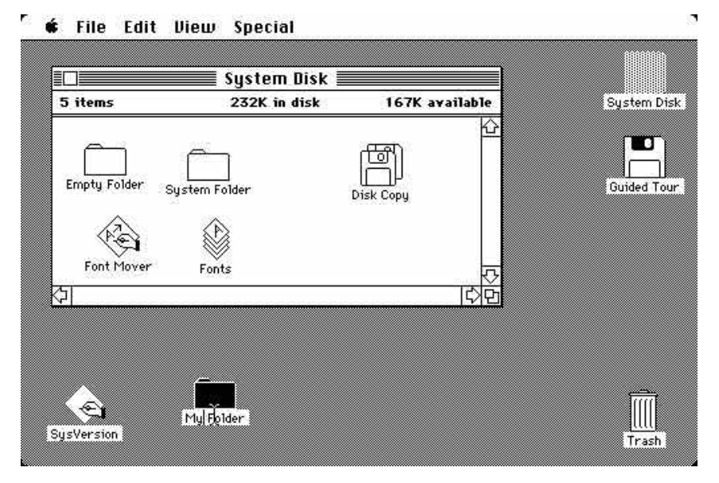

Figure 4: Apple Macintosh Desktop

1. Widespread Adoption of HCI Principles (1990s-2000s): The rise of the Internet and mobile devices further expanded HCI. Designers began to focus more on user experience (UX) and usability.
2. Modern HCI (2010s-Present): The field now includes advanced interaction technologies like virtual reality (VR), augmented reality (AR), gesture recognition, voice interfaces, and AI. The focus is on natural, immersive, and intuitive interactions that bridge the gap between human capabilities and machine intelligence.

**3. THE NEED FOR HUMAN-COMPUTER INTERACTION**

Human-Computer Interaction (HCI) is needed to make technology easy and comfortable for people to use. It improves how we interact with computers, making tasks faster and more efficient. HCI also ensures that technology is accessible to everyone, including people with disabilities. HCI is crucial in modern technology for several reasons:

**3.1 User-Centered Design (UCD)**

The essence of HCI is to design systems that prioritize the needs, preferences, and limitations of users. User-centered design focuses on the following:

* Ensuring technology is intuitive and easy to learn
* Reducing cognitive load by simplifying interfaces
* Creating flexible systems that adapt to the needs of diverse user groups (e.g., disabled individuals, elderly users, etc.)

**3.2 Usability and Efficiency**

The goal of HCI is to ensure that systems are **usable** that is, they should be efficient, effective, and satisfying to use. A poorly designed interface can frustrate users, leading to errors, wasted time, and decreased productivity. HCI aims to eliminate such issues by improving ease of use.

**3.3 Accessibility**

HCI ensures that technology is accessible to everyone, including individuals with disabilities. For example, voice commands, screen readers, and eye-tracking technology enable people with limited mobility or visual impairments to interact with computers.

**3.4 Improving User Experience (UX)**

HCI focuses on creating positive user experiences. A well-designed interface not only serves its functional purpose but also provides a pleasant and engaging experience for the user. Positive UX can lead to higher satisfaction, loyalty, and retention in business contexts.

**3.5 Reducing the Gap between Human and Machine**

One of the key goals of HCI is to narrow the gap between human cognitive capabilities and machine processes. It helps reduce the complexity of interactions with systems through natural interfaces, voice recognition, and smart assistants.

### **Module 1: Survey of Human-Computer Interaction Concepts, Theories, and Practice**

**2.2 Current HCI Practices**

Responsive Web Design (RWD): Building websites that adjust layout and functionality depending on the device used, whether it is a desktop, tablet, or smartphone.

Natural User Interfaces (NUIs)**: Interfaces designed to be intuitive by leveraging natural human behaviors, such as touch, gestures, and speech (e.g., touchscreens, voice assistants).

- **Wearable Technology**: Interfaces for devices such as smartwatches and fitness trackers, focusing on usability, comfort, and accessibility in mobile environments.

**4. APPLICATIONS OF HUMAN-COMPUTER INTERACTION (HCI)**

Today, technology has infiltrated every area of our life. Even if a person does not directly own or use a computer, computers have an impact on their lives. ATMs, railway ticket-selling machines, and POS machines are just a few examples of computer interfaces that people may interact with regularly without having to possess a computer. These applications show how HCI improves the usability and effectiveness of technology in various aspects of everyday life.

**a. Personal Devices (Smartphones, Tablets, Computers)**

HCI in Action: Touchscreens, voice commands, and intuitive interfaces allow users to interact easily with apps, send messages, browse the web, or make calls. Examples in iPhones and Android devices with user-friendly layouts, gestures, and voice assistants like Siri or Google Assistant.

**b. Gaming**

Interactive controllers, virtual reality (VR), and augmented reality (AR) provide immersive experiences where players interact with virtual environments. For example Oculus Rift (VR) or the PlayStation with motion-sensing controllers, and augmented reality in Snapchat filters.

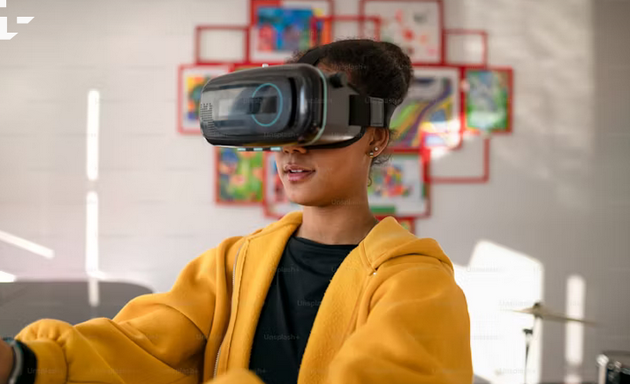

Figure 5: Oculus Rift (VR)

**c. Healthcare**

HCI are applied in medical devices with touchscreens, wearable health monitors, and surgical robots improve patient care and doctor-patient interaction. Examples: Robotic-assisted surgery (like the da Vinci system) and wearable devices like **Fitbit** and **Apple Watch** track heart rate.

**d. Automotive Industry**

HCI in Action: Touchscreen dashboards, voice-activated controls, and driver-assistance systems enhance safety and convenience in vehicles. Examples: **Touchscreen Dashboards** and voice commands for navigation or temperature control.

**e. Smart Homes**

Voice-controlled devices and apps that allow users to manage home appliances, lighting, and security remotely make use of HCI principles. Examples: Amazon Echo and Google Nest allow users to control lights, locks, and thermostats with voice commands.

**f. Education and E-learning**

HCI in Action: Interactive platforms and software allow students to learn through touch, voice, and visual interaction. Educational apps like Coursera, Photomath and virtual classrooms that use video conferencing tools.

**g. Banking and Finance**

HCI in Action: ATMs, mobile banking apps, and online trading platforms make financial transactions and management easier for users.